The Tasmanian Art Teachers Association Inc. (TATA)
Annual General Meeting (AGM)
October 19 2022 7pm –via Zoom
AGM Report 2022

Treasurers Report

The Tasmanian Art Teachers Association Inc. (TATA)
Treasurer’s Report for AGM
Reporting Period 4th November 2021 to the 19th October 2022.

Balance of TATA Accounts – 04/11/2021 to 19/10/2022

The balance of the TATA MyState Bank Account at the start of the reporting period was $27,555.05.

Income for TATA – 04/11/2021 to 19/10/2022

TATA’s income into the TATA MyState Bank Account for the duration of the reporting period was $909.66. (An increase of $105.02 compared with 2020/2021)
This included:
- $909.66 in membership through Stripe and direct credit for memberships.

TATA no longer holds a PayPal account.

All membership transactions that come in via the Website Form have now moved to Stripe. These payments are deposited directly into the TATA MyState bank account.

Expenses for TATA – 04/11/2021 to 19/10/2022

The operating costs and expenses for TATA over the reporting period were $3175.45.
This comprised of:
- Website related expenses including development of new website- $1845.45 (up $1070.45)
- Insurance for the TATA - to the amount of $344.00 (up $5.00)
- Annual Return of Association- $66.00 (down $87.90)
- PL related expenses - $920.00 (down $98.46)

Total Expenses for the reporting period was $3175.45. (up $558.18)

Current Balance of TATA Accounts

As of the 19th of October 2022, the current balance of the TATA MyState Bank Account is $25,289.26. The balance held in Stripe is $0.00.

There is no petty cash held by the TATA Treasurer for day-to-day purposes.

Further clarification on how monies have been transacted for the reporting period can be seen in Appendix 1, the MyState transactional history, and Appendix 2, the Stripe Reports Overview.

Appendix 1
Financial Report MyState Account – Item List
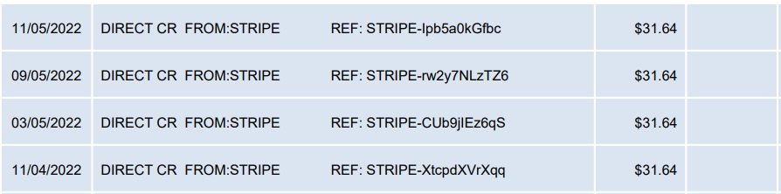
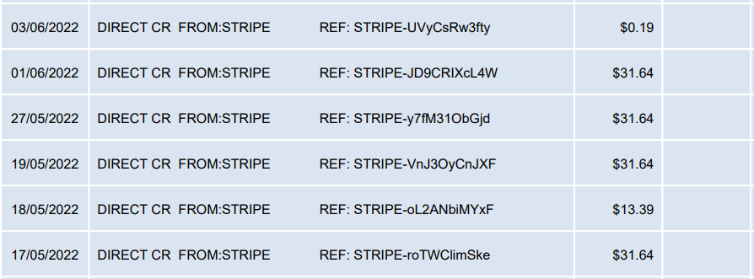
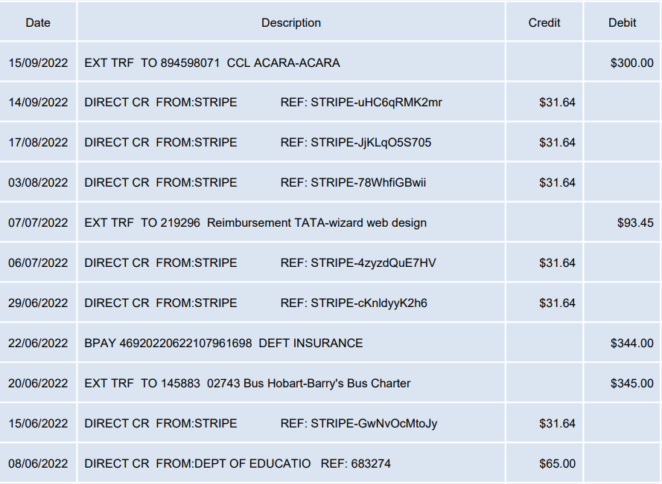
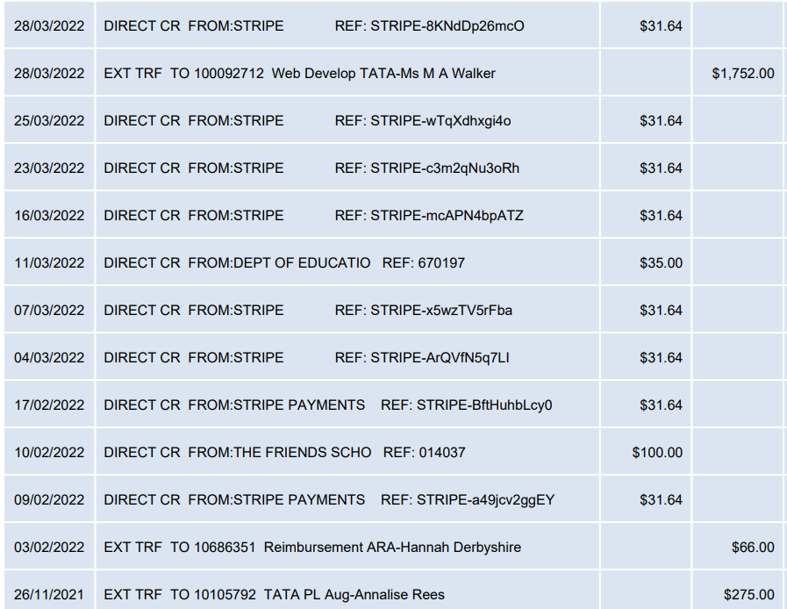

Summary | Amount in $
Balance Period Start | $27,555.05
Total Income | $909.66
Total Expenditure | $3175.45
Current Balance | $25289.26

President’s Report
TATA Social Media and Website
TATA continues to have a strong social media presence with 1000 on Facebook & 360 followers on Instagram. Our Facebook page continues to be our strongest platform to reach our followers on. A big thank you to Antonio Zanchetta and Abbey MacDonald for all their work in these spaces. TATA constantly posts on our Facebook page and Instagram account. We also use these spaces to answer queries from members and advertise events and share relevant information. To continue building this online presence we will elect a Social Media Councillor for 2023.
The new website, along with our new email address, has been a huge success. There has been a lot of hard work done by Michelle Walker to get this site up and running, and TATA paid for her time. However many hours of unpaid time have gone into mainting the website and Antonio Zancetta has been a huge help with this also. TATA are very grateful to both councillors for their ongoing efforts to make the website such a success.

Thank you to Hannah Derbyshire for all of her hard work keeping the Stripe account accurate and amending on going issues.

TATA Collaborations with Professional Arts organisations and events
TATA & Hadley’s Art prize
Thank you to Abbey Macdonald for all her work with this prize and including TATA in sponsoring the prize. This year we committed $1000 towards the prize, however in the end the prize only used $300 of this. We trialled a new sponsorship option where people could buy a ticket to the Changing Landscapes event and also receive a TATA membership. We gained 3 new members through this initiative. It may need to be discussed next year whether this initiative is worth pursuing into the future. The event was a huge success and many were in attendance despite a spike iin COVID cases during the time.

Salamanca Arts Centre X Tasmanian Art Teacher’s Gallery Hop
This event was held on June 11 over the long weekend and during Dark Mofo as well. The event included three locations, Salamanca Arts Centre, bett Gallery and Contemporary Arts Tasmania. At each event TATA members heard from exhibiting artists and curators including:
11am – 12pm
Curator + Artist Floor Talk
Long Gallery
Salamanca Arts Centre
The panel will consist of artists Kate Tucker, Alice Wormald, Eloise Kirk, Grant Nimmo and curator, Daine Singer
12.15pm -1.15pm
Break for lunch
Grab a bite to eat at the Salamanca Markets or bring along your packed lunch to relax nearby.
1.30pm – 2.30pm
Artist Talk
Bett Gallery
Join artist Meg Walch as she discusses her work and process.
2.45pm – 3:45pm
Curator talk on BioGym
Contemporary Arts Tasmania
Explore the boundaries between biology and culture, with an introduction from Curator, Lisa Campbell-Smith
This event was free for members. Unfortunately we only had six people in attendance. However, the event overall was a he success and Ainsley Macaulay organised all of it. This would be an event worth revisiting in the future. However, perhaps the timing needs to be looked at.

Prof Standards for teachers
2. Know the content and how to teach it
3. Plan for and implement effective teaching and learning
6. Engage in professional learning
7. Engage professionally with colleagues, parents/carers ad the community

TATA paid 2 artists of this event in line with NAVA rates. This event solidified TATA’s new relationship with SAC and a Memorandum of Understanding was drafted, finalised and signed off on earlier in the year for future events.

Future events with Salamanca Arts Centre & Gallery Seventy-One
In April/May of 2023 as part of the ongoing relationship that has been established with SAC, TATA will host a Member’s show beginning at SAC. This will ravel around the state. It will not cost TATA to exhibit with SAC as part of the ongoing relationship.

UTAS Panels
Kate Camm spoke on a UTAS Panel addressing students studying Master of Teaching about being a Visual Art Teacher. Thank you to Abbey MacDonald for organising these events and asking TATA to be a part of them.

Areas of priority against TATA Strategic Plan objectives – unchanged from 2021
This year the Strategic Plan was updated. Changes were made to the way the document looked in order to make it more accessible. We also focused more on the idea of safe and inclusive community heading into the future. TATA continues to value professional development and networking opportunities for our members. We hope future events such as the TATA Members Art Show with SAC will provide meaningful opportunities for networking, collaboration and professional development.
Page Break

Acknowledgments
Thank you to the TATA Executive and Council for your guidance and support this year. Your ongoing passion and enthusiasm for Visual Arts education has meant TATA has continued to grow and meet the needs of our members. Special Thanks to:
- Michelle Walker- Co- President
- Hannah Derbyshire- Treasurer
- Sarah Brooke- Secretary / Vice President (replaced Steve Richter in August)
- Antonio Zanchetta- Webmaster and Social Media Communications
- Miriam Berkery
- Steve Richter (resigned)
- Jan Hogan- Councillor
- Abbey MacDonald- Councillor
- Luke Viney- Councillor
- Caz Saunders- Councillor
- Bree Taylor- Councillor (resigned)
- Melissa Heathorn- Councillor (resigned)

Kate Camm
President 2022

