Family & Friends

Robin Ranga, An Offering, 2019, unglazed earthenware and paper clay 380 x 3,800 (overall) x 55mm
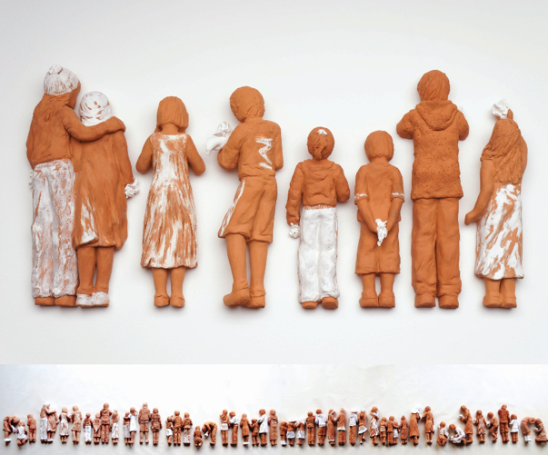

People’s choice winner of the Portage Awards

This beautiful piece made of 51 earthenware and paperclay figures, carries a message of unity, tolerance and harmony, shining light upon a new and enlightened generation.

Learning Intentions
- Builds awareness and understanding about what defines relief sculpture. This will include bas relief and high relief examples from different cultures and times, including contemporary use.
- Develop skills to sketch from life, capturing people doing everyday tasks and relaxing at home.
- Develop refinement with sculpting techniques using coiling, joining and modelling techniques.
- Capture proportions, posture, features and clothing details of figures.

Learning Experiences
- Research relief sculpture, documenting examples from different cultures and times.
    - Relief sculpture definition https://www.youtube.com/watch?v=KdApq0Nh-0U
    - Historical examples of relief sculpture https://www.metmuseum.org/toah/keywords/relief-sculpture/
    - A modern take on relief sculpture https://mymodernmet.com/relief-sculpture-artists/
- Plan and make a series of relief sculpture figures, inspired by the work of Robin Ranga. The subject matter will be your family, pets and friends.
- Written response to an artwork by the artist Robin Ranga

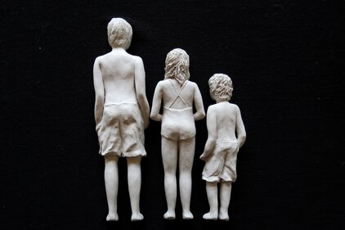
What you need to do
- Make a collection of relief sculpture images from different cultures. Organise them in a timeline starting with the oldest. Your page or screen should be in landscape format, use between
15 - 20 images. Complete this as a word document, slide show, video, or PowerPoint presentation. The Met Museum site is a great resource. Record the details for each image. Keep a reference list. What is your favourite example and why. Upload this document to SEQTA.
- Planning and designing in your journal. Collect photos of your family and friends, you should also make a series of drawings and quick little sketches from life, capture what your family (and pets) are doing around your home. They don’t need to be big drawings, 2 pages in your journal.
Siblings, Robin Ranga

Use your sketches and photos as the basis for a relief sculpture for several figures. The group of figures (and pets if you like) will need to fit within an A4 sized piece of paper. The figures can be standing, sitting, active, facing forwards or backwards, as you see in An Offering.
If you have time and feel inspired you can make two groups. 1. family on one A4 page and 2. friends on another A4 page. You will need Terracotta clay, white underglaze, modelling tools.

- Analysis and Reflective Response – Artist, Robin Ranga
Extract from the artists web site

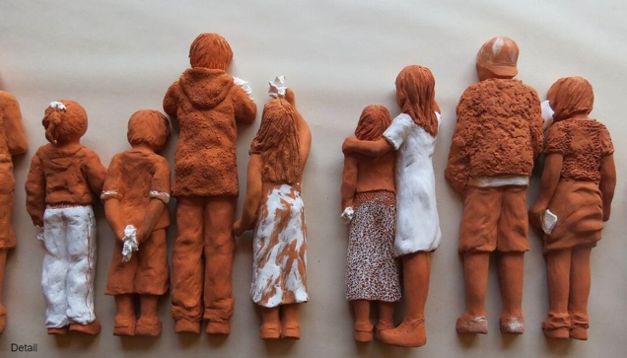
A multi-media artist she has won recognition in both ceramics and painting.
Since 2016 her practice has evolved into exploring and creating a visual platform concerning the plight of the displaced and the marginalised, who have faced oppression, prejudice and conflict. With a perception that humans of all hues, race or tribe, are a global family - members of immeasurable communities of settlers, all striving to live and flourish, her works focus on how humanitarian and social justice matters impact on the lives of children, families, society and countries.
Using art as her conduit through her practice, Robin strives to create an awareness and notions of empathy to provoke responses of compassion, tolerance and hope for better understanding between differences in ideology and perceptions.
The most recent work An Offering was her response to the massacre in Christchurch 15 March 2019. Starting the next day with one little girl holding flowers and the first line of the words that eventually accompanied the work took 4 months and was an emotional journey. It became an expression of compassion to those who have suffered through conflict in ideology and oppression, a tribute to those who contribute in a myriad of ways to help comfort those in pain and sadness, and finally a message of hope through the eyes of children to teach us lessons in tolerance, respect and humility.
Detail, An Offering, Robin Ranga

Robin Ranga http://www.robinranga.nz/

Analyse and evaluate how Ranga’s personal experience and her application of elements and principles of design in the artwork An Offering, communicates her intention, that this work is an expression of compassion.
In your response you should address the following:
- What relationship does the artwork have to the artists life and experiences? How is the artwork linked to people, places and experiences of personal significance to the artists, such as – personal feelings, ways of thinking, beliefs, memories….
- What visual evidence supports this? What material and techniques have been used? How do the materials or technical skills used affect the interpretation of the work?
- How do the formal elements and principles of composition – focal point, balance, texture, shape, form, scale, colour, tone etc….help to communicate the artist’s message?
- How does the experience and background of the viewer affect the interpretation of the artwork. Does your current lived experience make you look at this work in a different way than it was intended? Explain your reasons. https://www.teuru.org.nz/teuru/assets/File/Portage%202019/Portage%20Publication%20low%20res%202019.pdf
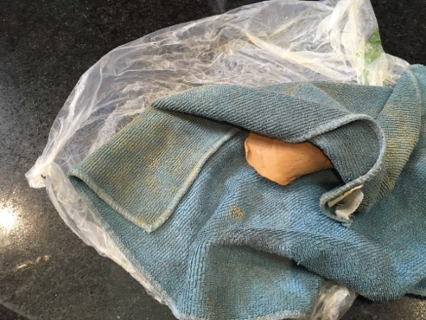
Take Home Pack – you will need

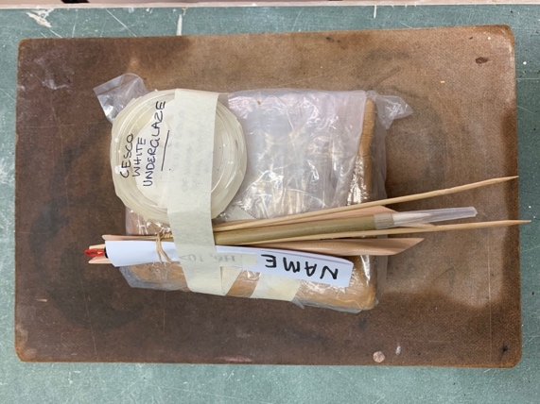
Equipment and materials
- Clay - School terracotta 1/4 -1/3 of a packet
- 2 Tbs cesco white underglaze
- A4 paper and board
- pencil
- Wooden skewer
If the clay scraps dry out, wrap them in a damp cloth and store in a plastic bag overnight
- Wooden modeling tool
- Paintbrush
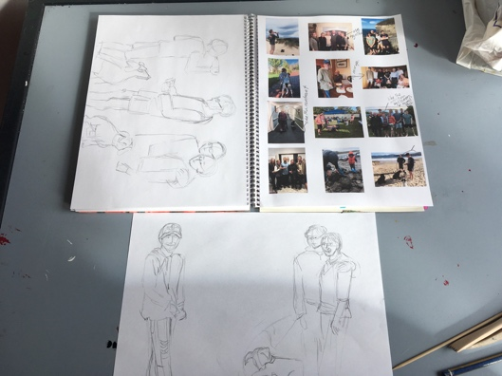
- Fishing line

Planning in the journal
Photos and drawings.
Final plan on A4 paper

Techniques
How to make slurry – video
Making the relief sculpture - video
Coiling
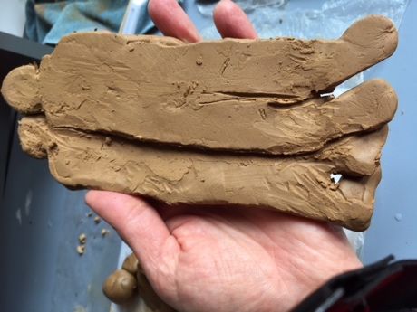
Joining
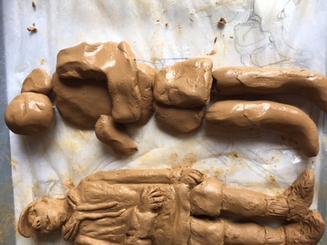
Adding details
texture
Appropriate thickness of clay
Painting on underglaze, when the clay is leather hard
Finish the back and write your name on all the figures on the back

Outcome and assessment
Making
Manipulate materials, techniques and processes to develop and refine techniques and processes to represent ideas and subject matter in their artworks
- Consider, select, and use ceramic technologies and techniques to develop ideas and designs carefully and creatively;
- Demonstrate a high degree of willingness and success in attempts to improve personal skill competency levels and techniques .
Identify and incorporate influences of other artists on their own artwork
- The influence of Robin Ranga’s ceramic practice is obvious in the students artwork. They can discuss her impacted on their own art work.
Responding
Evaluate how representations communicate artistic intentions in artworks the student makes and views
- Follow the design process and evaluate the effectiveness of the plans you have devised and justify any adaptions you needed to make as you completed the activity
- Speculate on the intent of artists based on observed works with a significant degree of insight
Analyse and evaluate artworks and displays from different cultures times and places
- Offer detailed and accurate comments on the historical and cultural contexts in which the art work was produced;

