The Elements of Art

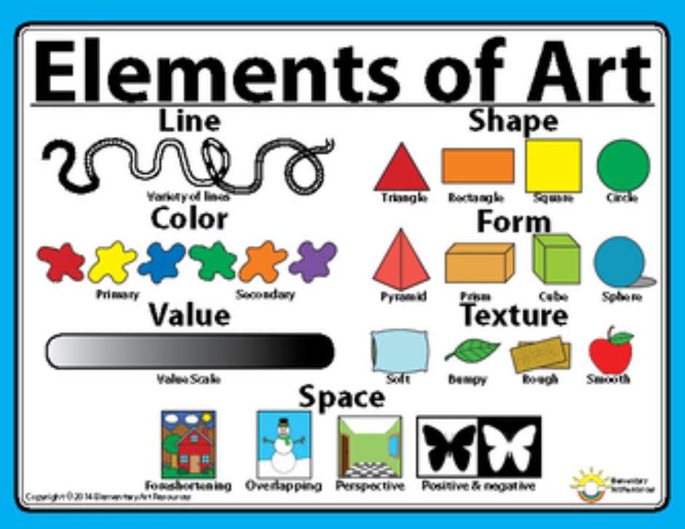

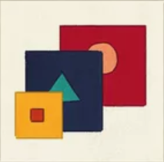Match the element to the correct image:

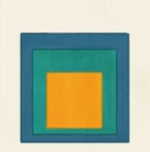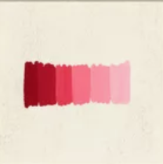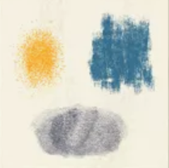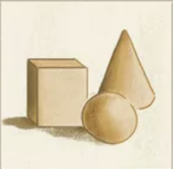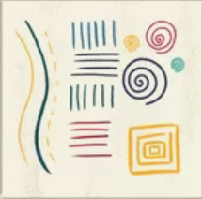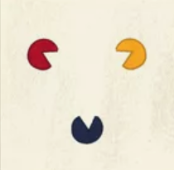

Shape

Colour

Space

Form

Value

Texture

Line

List the three elements you can see in these places:

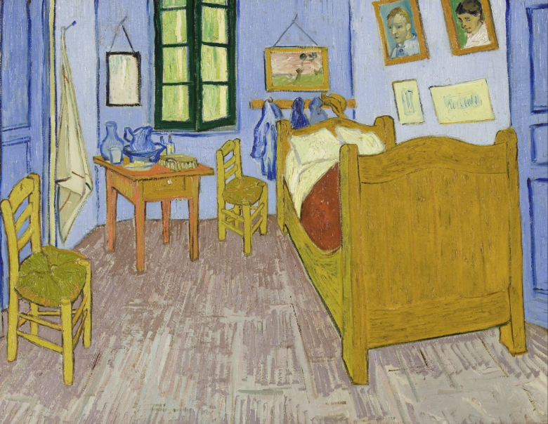

|  |
| --- |
| Vincent’s Bedroom in Arles, 1888 by Vincent Van Gogh |

Draw an image in this space using Shape, Colour and Texture:

Draw a line to:

* Line
* Colour
* Texture