Can you create mandala patterns using objects you find around your home?

What is a mandala?

The word mandala means “circle” in Sanskrit. A mandala is a circular pattern with radial symmetry. Mandala art begins with a central point and all other lines and objects radiate out from the centre.
You can find mandalas all around you, both in the natural world (flowers, tree rings, spider webs, eye balls) and in the technology people have designed (bike tyres, wheels, fans).
Some people create mandalas to help them relax. The best thing about creating your own mandala art is that you can choose any shapes and colours you want.
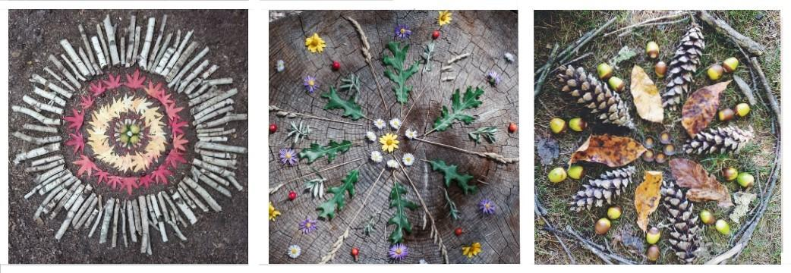
Gather materials you could use:
- It could be natural objects you find outside: leaves, twigs, rocks, grass, flowers.
- It could be objects you find inside: pegs, toys, legos, pencils.
- Try to find a variety of different shapes, sizes and colours.

Get creative:
You might find it easier to start with an object in the middle and then create a small circle around that object.
How many different ways can you make a mandala re-using the same objects?

