Small World: Design Challenge
We are learning to:
- Design and create a small world
- Experiment with different materials to create two-dimensional shapes and three-dimensional objects
This is because creating small worlds encourages imagination and helps you to develop your creativity and problem-solving skills.
…………………………………………………………………………………………………………………………………….
ASK and IMAGINE:
- Brainstorm ideas. What kind of small world will you create? (for example: miniature zoo or animal habitat, model city, dinosaur land, fairy town, secret garden – anything goes!)
- What features will your small world include? (for example: roads, pathways, fences or barriers, mountains, caves, rivers, huts)
- Where could you build your small world?
- What objects and materials will you need?
PLAN:
- Which two-dimensional shapes and three-dimensional objects will you use in your design?
- Draw a sketch / diagram / map of what your world might look like
- Label your plan
- List the objects and materials you will need to find
- Gather the materials you need
CREATE:
- Follow the plan to build your design

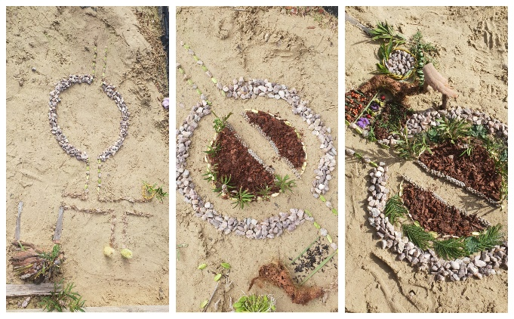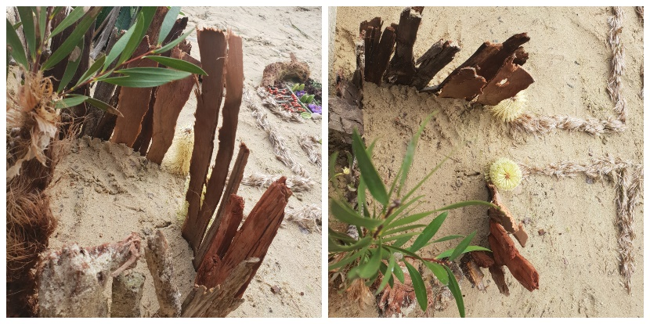

IMPROVE and REFLECT:
- Play with and test your design. How can you make your design even better?
- Are there any parts of your plan that you needed to change?
- If possible, take photos of your mini world creation to share and reflect with your class
